**Calculator Free**

**Sets and Set Notation**

Time: 45 minutes

Total Marks: 45

Your Score: / 45



**Question One: [2, 2 = 4 marks]**

Shade each of the following regions:

1.  (b) 



**Question Two: [1, 2 = 3 marks]**

Describe the following shaded regions using set notation.



(a) (b)**Question Three: [1, 2, 2, 2, 4 = 11 marks]**

Consider the following sets:

U = {counting numbers from 1 to 20}

A = {prime numbers in the universal set U}

B = {factors of 20}

C = {multiples of 4 in the universal set}

Determine:

1. 
2. 
3. 
4. 
5. State whether the following statements are True (T) or False (F)

(i) 

(ii) 

1. 
2. 

**Question Four: [8 marks]**

Place each of the following animals in the correct region in the Venn diagram below.

Dog

Spider

Fish

Prawns

Whale

Jellyfish

Humans

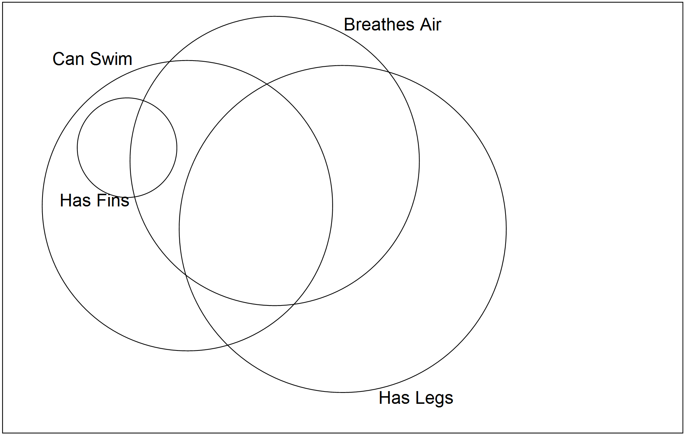Water Viper (snake)

**Question Five: [5 marks]**

200 people were asked whether they had flown internationally (I) or domestically (D) in the past 12 months.

* The ratio of those who had flown domestically to those who hadn’t was 3:1
* 10% had flown both internationally and domestically.
* A fifth of those who hadn’t flown domestically, had flown internationally.

Use the above information to complete the Two-Way Table below.

|  |  |  |  |
| --- | --- | --- | --- |
|  | **I** | **I’** | Total |
| **D** |  |  |  |
| **D’** |  |  |  |
| Total |  |  |  |

**Question Six: [2, 2, 2, 2 = 8 marks]**

The following eight girls are involved in at least one of the following sports: Basketball (B), Softball (S) or Football (F).

*Lisa, Nikki, Becca, Amy, Martina, Melanie, Sofia, Nadia*

The following information is known:











Determine:

1. 
2. 
3. 
4. 

**Question Seven: [4, 2 = 6 marks]**

A survey on the 150 students from the leaving class of 2013 at Lowfields College were asked whether they were involved in work or study in 2014.

The number working and studying was four times as many only involved in work.

The number studying and not working was 45 less than those doing both.

15 students weren’t doing either of these.

1. Use the above information to complete the Venn diagram below.

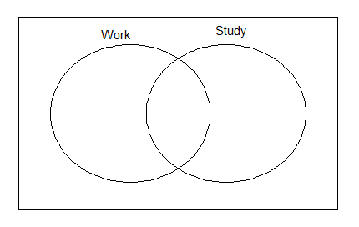

1. What proportion of those who worked also studied?

**SOLUTIONS**

**Calculator Free**

**Sets and Set Notation**

Time: 45 minutes

Total Marks: 45

Your Score: / 45



**Question One: [2, 2 = 4 marks]**

Shade each of the following regions:

1.  (b) 

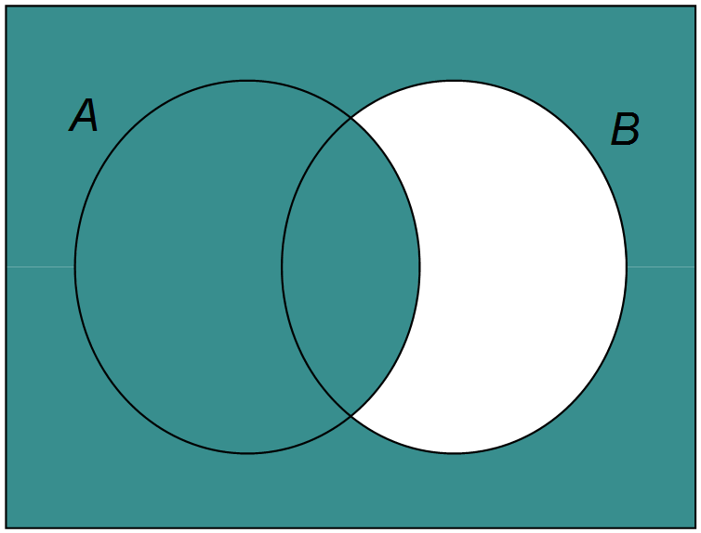

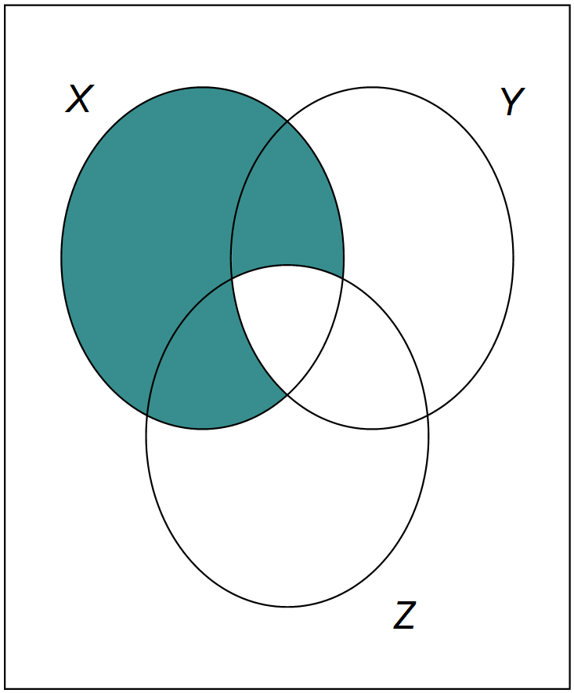







**Question Two: [1, 2 = 3 marks]**

Describe the following shaded regions using set notation.



 (a) (b)**Question Three: [1, 2, 2, 2, 4 = 11 marks]**

Consider the following sets:

U = {counting numbers from 1 to 20}

A = {prime numbers in the universal set U}

B = {factors of 20}

C = {multiples of 4 in the universal set}

Determine:



1.  8



1.  {4, 20}
2.  {6, 8, 9, 12, 14, 15, 16, 18}



1.  15
2. State whether the following statements are True (T) or False (F)

(i) 

False

(ii) 

True

1. 

True

1. 

True

**Question Four: [8 marks]**

Place each of the following animals in the correct region in the Venn diagram below.

Dog

Spider

Fish

Prawns

Whale

Jellyfish

Humans

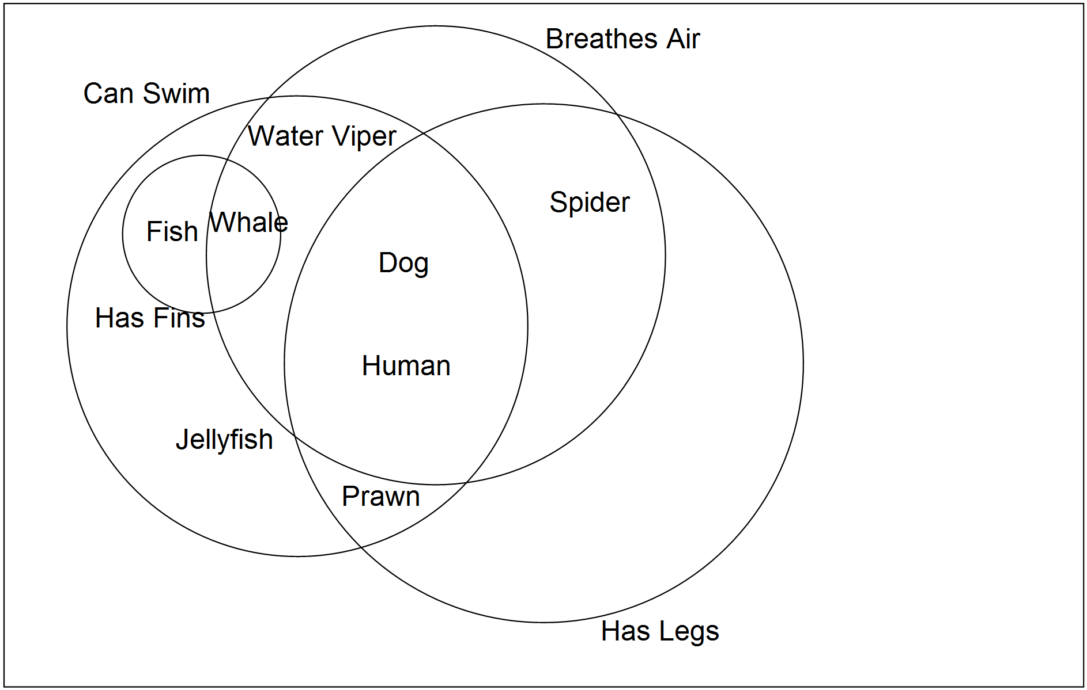Water Viper (snake)



**Question Five: [5 marks]**

200 people were asked whether they had flown internationally (I) or domestically (D) in the past 12 months.

* The ratio of those who had flown domestically to those who hadn’t was 3:1
* 10% had flown both internationally and domestically.
* A fifth of those who hadn’t flown domestically, had flown internationally.

Use the above information to complete the Two-Way Table below.

|  |  |  |  |
| --- | --- | --- | --- |
|  | **I** | **I’** | Total |
| **D** | 20 | 130 | 150 |
| **D’** | 10 | 40 | 50 |
| Total | 30 | 170 | 200 |



**Question Six: [2, 2, 2, 2 = 8 marks]**

The following eight girls are involved in at least one of the following sports: Basketball (B), Softball (S) or Football (F).

*Lisa, Nikki, Becca, Amy, Martina, Melanie, Sofia, Nadia*

The following information is known:











Determine:

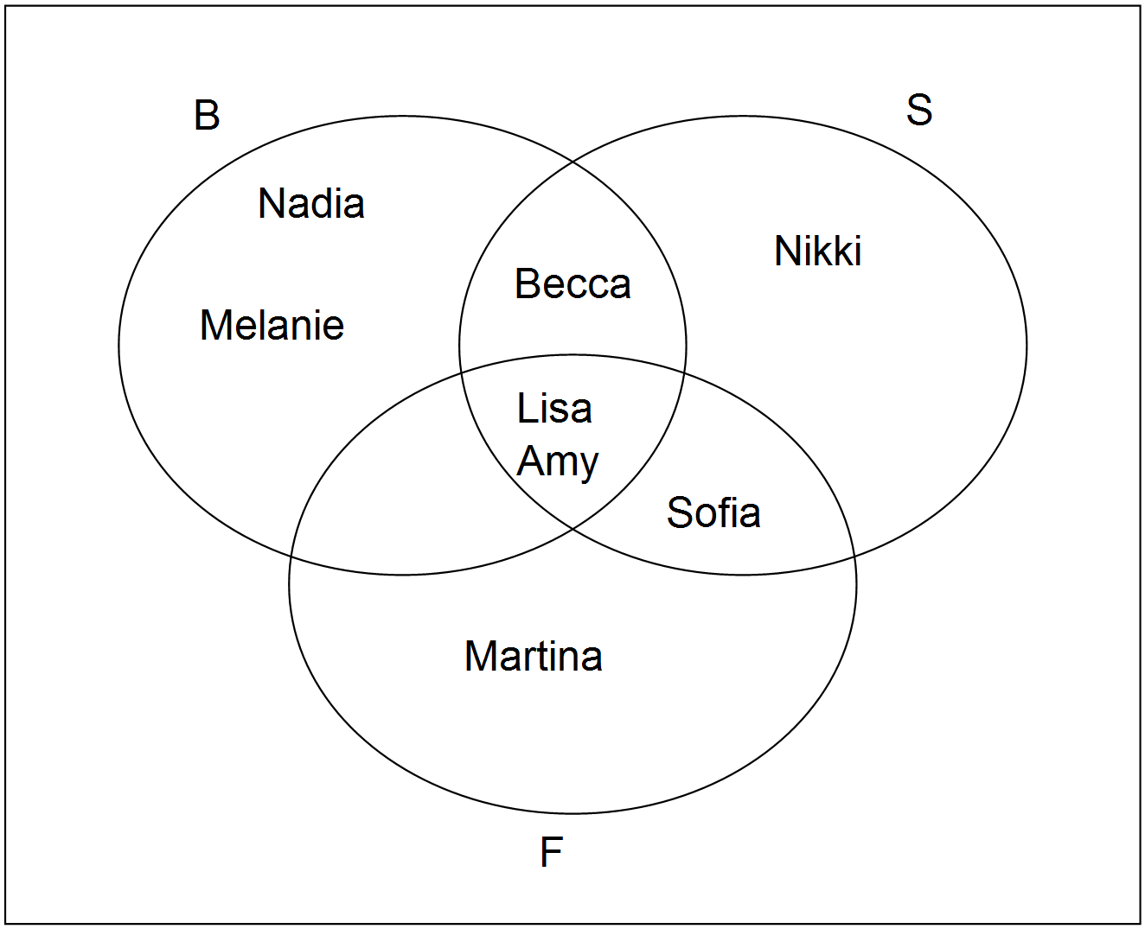

1. 

{Lisa, Amy, Sofia, Martina}

1. 



2

1. 

3

1. 



{Nikki, Becca, Lisa, Amy, Sofia, Martina}

**Question Seven: [4, 2 = 6 marks]**

A survey on the 150 students from the leaving class of 2013 at Lowfields College were asked whether they were involved in work or study in 2014.

The number working and studying was four times as many only involved in work.

The number studying and not working was 45 less than those doing both.

15 students weren’t doing either of these.

1. Use the above information to complete the Venn diagram below.

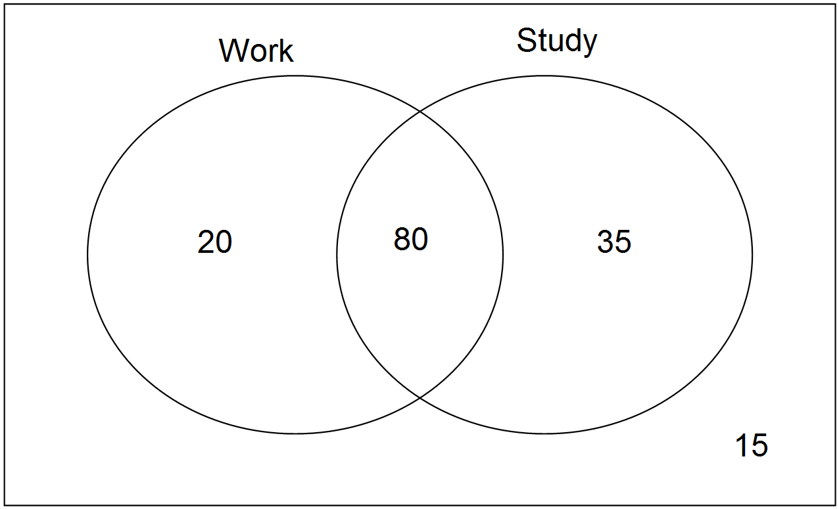





1. What proportion of those who worked also studied?



80%